spring 5, boot 2, jpa, thymeleaf, aop, REST

course notes

Spring framework was to make java enterprise applications.
Helps you create web app, mobile app, expose a public api spring can help you bootstrap your application in minutes

In the course we use java on framework and sql.

Abstract of Spring

Ecosystem of spring helps you concentrate more on the business logic instead of tying you to setting up the ecosystem.

Spring is modular by design

Spring core
Support for dependency injection and
Transaction management.

Abstract of SpringBoot

Spring boot is a component in spring that helps you kick start an application in minutes. It favours convention over configuration. It does all the auto configuration of third party library to start the application

@GetMapping(/user/{userId}/invoice)
public String getInvoice(@PathVariable Integer userId, @RequestParam(value=””,required=false) Date dateOrNull)

@Pathvariable value is always picked from the url

AUG-01
SEP-02
OCT-03
24/08/21
12 days we count weekends and
Amount get in email
Convert it to pdf and send
1st column my name
2nd column reporting manager
Create drive

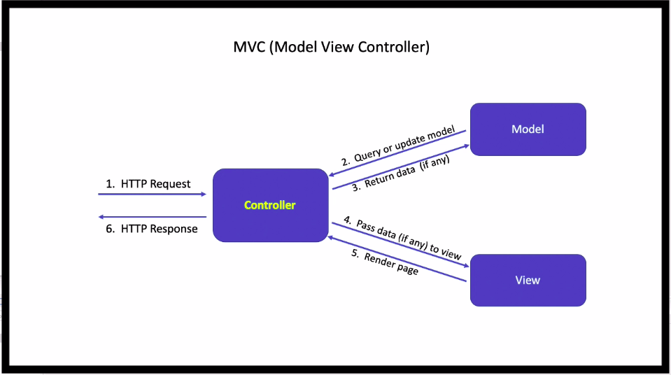

Views in mvc
The views are created in the template directory and we use thymeleaf for creating the views.

Controller in mvc
@Controller vs @RestController
The @Controller is a common annotation that is used to mark a class as Spring MVC Controller.

@Controller looks for the webPage in template directory to be rendered on the webpage

while @RestController is a special controller used in RESTFul web services.
@RestController is used to make and serve rest apis.

Model in (Mvc)
To send data and retrieve data from a webpage we use a model.
Model model(org.SpringFramework.ui)
model act as a mapper between the view and the controller
Its model.addAttribute(“formData”,new Person())
Its take a string key i.e the formData and a new Person() as the

example--->
@GetMapping(path = "/landingForm")
public String landingForm(Model model){
model.addAttribute("personData",new Person());
return "landingForm";
}

Thymeleaf template

It acts as the view.that we show to the end user on the browser.
It's stored in a template folder as a html file.
To convert html in thymeleaf we write the following command.
<html lang="en" xmlns:th="http://www.thymeleaf.org">

To specify the model key which will bind the template (let say a form) to the object/entity

<h2>Fill out the form</h2>
<form action="/homePage/process-person-data" method="POST" th:object="${personData}">
<p>Full Name:<input type="text" th:field="${personData.fullName}"/></p>
<p>Age:<input type="number" th:field="${personData.age}"/></p>
<p>Are You Employed:<input type="checkbox" th:field="${personData.employed}" th:value="true"/></p>
<p>Choose Gender</p>
<p>Male:<input type="radio" th:field="${personData.gender}" th:value="Male"}/><br/>
Female:<input type="radio" th:field="${personData.gender}" th:value="Female"}/><br/>
</p>
<p><input type="submit" value="Submit"> <input type="reset" value="Reset"></p>
</form>
th:object=”${takes the key you specify in the controller in model.addAttribute(“personData”,new Person()) }”

Redirect in spring mvc
public String processFormData(Person person, RedirectAttributes attributes){
// redirect data to another page
// here we store data in database
attributes.addFlashAttribute("person",person);
return "redirect:/homePage/show-person-data";

attribute.addFlashAttribute() is the function of RedirectAttribute interface which helps you to pass the data to the redirected outPut

Here we are passing the person data to the redirected page.

@GetMapping(path = "/show-person-data")
public String showFormData(Person person) {
return "resultOfLandingForm";
}

The above redirected page will take the object passed in the argument and

